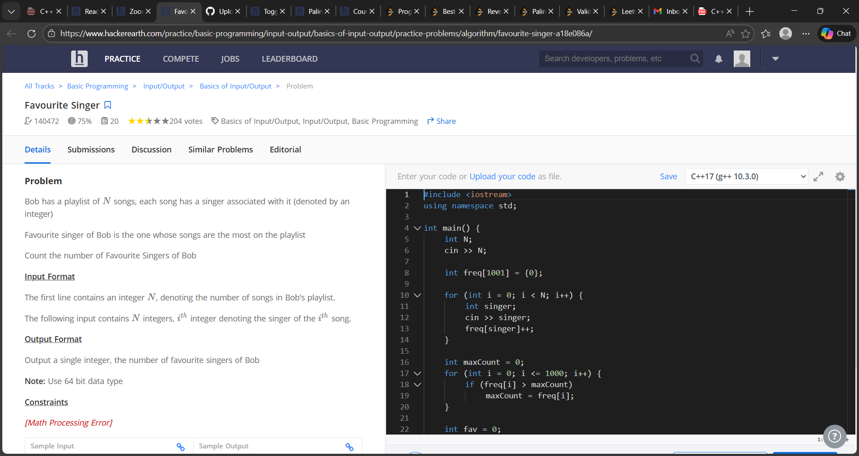

#include <iostream>
using namespace std;
int main() {
int N;
cin >> N;
int freq[1001] = {0};
for (int i = 0; i < N; i++) {
int singer;
cin >> singer;
freq[singer]++;
}
int maxCount = 0;
for (int i = 0; i <= 1000; i++) {
if (freq[i] > maxCount)
maxCount = freq[i];
}
int fav = 0;
for (int i = 0; i <= 1000; i++) {
if (freq[i] == maxCount)
fav++;}
cout << fav;
return 0;
}

